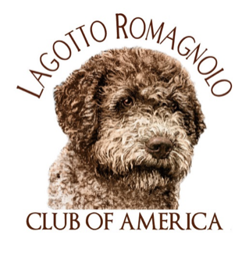On behalf of the LRCA we want to thank the following for their Trophy Sponsorship & General Fund donations for this year’s National Specialty. These donations are paramount in the LRCA’s ability to hold National Specialties each year. Your generosity is truly appreciated!

Catherine Elder, 2022 LRCA National Specialty Show Chair
Jim Talbert, President LRCA

Regular & Non-Regular Classes
Best of Breed | Debra Ann, Isabella & Luna Hooper | Best of Opposite Sex | Barry Wagner
Best of Winners | Paula & Kevin Miller | Select Bitch | Jim & Carolyn Talbert – LambsCreek
Select Dog | Barry Wagner | Winners Dog | Drenda Montgomery
Award of Merit | -Jim & Kimberly Beach, Diamante  -Lisa Sobon, Lori Engel &  Drenda Montgomery  -Susan and Keith Couch | Winners Bitch | True Blue Kennel, Elaine Randall
Reserve Winners Dog | True Blue Kennel, Elaine Randall | Reserve Winners Bitch | True Blue Kennel, Elaine Randall
Dog Classes | -Cynthia Drumbor  -Jean Davis-Barger  -Jim & Amy Dickey  -Elizabeth Reese  -Kim McGuirk - Newbliss | Bitch Classes | Susan and Keith Couch
Stud Dog | Debra Ann, Isabella & Luna Hooper | Brood Bitch | Puppy Culture
Best Bred By Exhibitor | Mel & Hilarie Sykes - Lagotto del Tiglio | Best Puppy in Classes | Drenda Montgomery
Best Junior Handler | Amy Lane – Allegiance
Best Head | Mel & Hilarie Sykes - Lagotto del Tiglio | Best Coat | Mel & Hilarie Sykes - Lagotto del Tiglio
Best Construction & Movement | Mel & Hilarie Sykes - Lagotto del Tiglio

Sweepstakes
Best Puppy | Catherine Elder & Lisa DiStefano - Lilyfield | Best Veteran | Barbara & Richey Johnston
Best Opposite Sex -Puppy | Barbara & Richey Johnston | Best of Opposite Sex -Veteran | Barbara & Richey Johnston
Puppy Dog Classes | Amore Lagotto | Veteran Dog Classes | Linda Belleau
Puppy Bitch Classes | Amore Lagotto | Veteran Bitch Classes | Linda Belleau

General Trophy Fund
Platinum | Gold | Gold
Robin Skiles | Drenda Montgomery | Karen Olesen
Barbara & Richey Johnston | John DiGiogio

The LRCA would also like to thank Ricky Helton, Ricky Helton Photography for donating his time & talents as our Specialty Ring Photographer.

