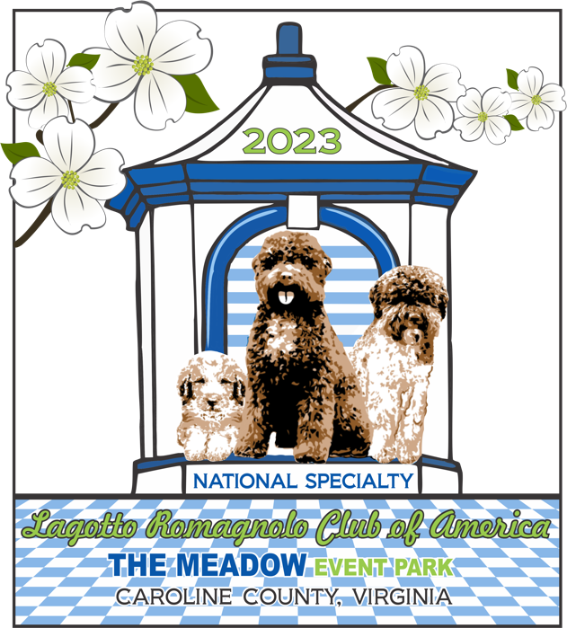Lagotto Romagnolo
Lagotto Romagnolo
Club of America

National Specialty 2023
March 25th, 2023

Supported Entries March 23, 24, & 26, at The Meadow Event Park Pavilion, 13191 Dawn Boulevard, Doswell, Virginia 23047

From Bagnara di Romagna, Italia our National Specialty Judge is the esteemed Professor Giovanni Morsiani and Sweepstakes Judge Dinora Venturi Morsiani.

The National Specialty is an event for anyone that loves Lagotti. There will be events for everyone to train and learn about our dear fur family.
We even have events for humans to interact without social distancing.
Don’t live a life of regret, be there, have fun, and enjoy the Lagotti Life... Zoomies for everyone.

NEW LRCA Members FREE Thursday, 12:00-2:00, Lagotti Grooming Demonstration, The Pavilion with Allison Bacelli, is a professional groomer, trained by Haley Keyes at Nanhall School of Grooming. She has been grooming Lagotti since 2014 and maintained several show coats, with a few of her haircuts placing at National Specialties. Non-members, $15.00

NEW LRCA Junior Members FREE Complimentary Buffet Judge’s Dinner for Lagotti Junior Handlers on Saturday, March 25th, but you MUST register.

NEW See page 7 for Grooming, Crates, Tents, & Chairs

March 25th, Saturday, Buffet Judge’s Dinner at The Mansion, Check for purchase at www.LagottoUS.com

A free special presentation by Claire A. Wiley, VMD, DACVIM, Executive Director, AKC DNA will inform us on DNA issues.

The Silent Auction on Saturday night is open to all with some beautify and useful items.

Be sure to purchase your spirit wear before the store closes on February 27th. This year we have some great products.

Proceeds from some fun activities on Saturday night will go the Lagotto Romagnolo Dog Rescue.

Check out the Italian Flag Dog Bandanas, offered by Ann Sweeting, for each Lagotto attending the National Specialty that is registered in Conformation or in any event.

LRCA Host Hotel:(No events will be held in the Host Hotel) (ALL activities will be held at The Meadow Event Park Pavilion or next door in The Mansion.)
I was able to open more rooms!!!
DEADLINE for booking until 3:00 p.m. on MARCH 3RD
There is a regional soccer tournament this weekend. Rooms will go fast…
Hampton Inn by Hilton Richmond – North / Ashland
705 England Street, Ashland Virginia 23005
Tel: 804.752.8444 Fax: 804.752.8445
Group Code; NSC or C-NSC
Group Name; National Specialty
Contact: Vonshea Wimberley, 804.752.8444, Vonshea.Wimberley@hilton.com

The Meadow Event Park, RV Parking:
We will have 24 RV hookup sites withing 200 feet of The Meadow Pavilion. All of our activities and Judge’s Dinner will be within 300 feet of the RV(Pavilion) Hookup Sites.
Official RV Registration will appear in the Premium as list at $60/Night. (Water & Electric / Dump Station)
NOTE: You must check Upper lot near Lagotto to be next to our venue. Otherwise, you will be down the hill at the all-breed RV parking.

RV Parking Reservation Application Overview
(The form will be in the Premium)
- A confirmation will be sent only if a self-addressed, stamped envelope is enclosed.
- Application must be received by March 8, 2023, DEADLINE
- No refunds after close of entries.
- Make checks payable to: Langley Kennel Club, Inc.
- Wednesday, Thursday, Friday, Saturday & Sunday, $60.00 per night with Electric.
- RV Parking is available starting at 12:00 Noon Wednesday, March 22, 2023
- Those arriving without a reservation will pay an additional $10.00 per night.
- Name, Address, City/State/Zip, Phone Number, Type of Vehicle, Total Length of Unit, License Plate State & Number, Handicapped, Estimated Time of Arrival
❏ Check here for RV Parking in upper lot near Lagotto specialty building.

Outside Event Venue Campground
KOA, 10061 Kings Dominion Blvd., Doswell..................................................(804) 876-3500

RV rentals are available from;
RVShare, https://rvshare.com/?semid=bing.b&placement=s&campid=234390103&adgid=4524404540&keyword=e.rvshare&copyid=81776228267964&kwd-81776343962903%3Aloc-190=&device=c&loc_physical=92915&loc_interest=&camptype=search&msclkid=b076fa91739916c01d3c99c63f41d9f7

RVezy, https://www.rvezy.com/

Good Sam RV Rental, https://www.rvrentals.com/

Directions to the Event Site:
From Washington, DC: Take US-1 South/14th St. Bridge. US-1 becomes I-395 South. I-395 South becomes I-95 South. Take the VA 30 exit, Exit 98 toward Doswell/West Point. Turn left onto VA-30 Exit/Kings Dominion Boulevard. Follow approximately 1.8 miles to The Meadow Event Park. Use Gate #3.
From Fredericksburg, VA: Take VA-3 West to I-95. Merge onto I-95 South toward Richmond. Take the VA-30 exit, Exit-98 toward Doswell/West Point. Turn left onto VA-30 Exit/Kings Dominion Boulevard. Follow approximately 1.8 miles to The Meadow Event Park. Use Gate #3.
From Richmond, VA: Take I-95 North towards Washington. Take VA-30 Exit, Exit 98 toward Doswell. Merge onto VA-30 Exit toward West Point/Kings Dominion. Follow approximately 1.6 miles to The Meadow Event Park. Use Gate #3.

The Meadow Pavilion will be our “Ring” for the entire four days, with three days of Supported Entry and our National Specialty.
The 6,984 total square-foot Meadow Pavilion is a multi-purpose facility bathed in light from its central skylight and sectional glass doors. It offers parking adjacent to the building, and the eight doors can be left open in warm weather. This a heated venue with concrete floors. A large industrial fan provides excellent air circulation.
Hookup for 24 RVs is within 100 feet of the building. https://meadoweventpark.com/meadow-pavillion

About The Meadow Event Park:
Birthplace and home of Secretariat (March 30, 1970 – October 4, 1989), also known as Big Red, was a champion American thoroughbred racehorse, born at The Meadow, Doswell VA, who is the ninth winner of the American Triple Crown, setting and still holding the fastest time record in all three races. He is regarded as one of the greatest racehorses of all time. He became the first Triple Crown winner in 25 years and his record-breaking victory in the Belmont Stakes, which he won by 31 lengths, is widely regarded as one of the greatest races in history. During his racing career, he won five Eclipse Awards, including Horse of the Year honors at ages two and three. He was nominated to the National Museum of Racing and Hall of Fame in 1974. In the List of the Top 100 U.S. Racehorses of the 20th Century, Secretariat is second only to Man o' War. Audio Tour of Farm, https://www.youraudiotour.com/tours/1570/

Special Presentations / Requiring Registration

March 23rd, Thursday, 12:00-2:00, Lagotti Grooming Demonstration, The Pavilion. Registration will be posted on www.LagottoUS.com

March 23rd, Thursday, 2:00-4:30, Scent Work Seminar, The Pavilion, offered by Meg Lockwood. There will be limited registration for these programs which will include two workshops, one for beginners and one for advanced scent work with two categories, working dog with a handler and a handler without a dog. Registration will be posted on www.LagottoUS.com

March 24th, Friday Afternoon 1-4 p.m., AKC Judges Education Seminar, The Mansion 2nd Floor West Wing, Contact Adrienne Perry at allegrolagotto@gmail.com (Free for members, Learn about the history, form, and function of Lagotti)

March 25th, Saturday, Noon, Box Lunch at The Pavilion,
Register to purchase at www.LagottoUS.com

March 25th, Saturday, 2:30-5:00, The Mansion, Breed Education; Presented by Professor Giovanni Morsiani. "Judgement criteria in dog shows of the Lagotto Romagnolo with notes on the main characters of the type in the breed.” Limited registration for anyone interested. This will be the first time this presentation has been presented in the USA (Presentation will be in English.) Registration will be posted on www.LagottoUS.com FREE for LRCA Club Members and Judges

March 25th, Saturday, Buffet Judge’s Dinner at The Mansion,
Register to purchase at www.LagottoUS.com
FREE Complimentary Dinner for Junior Handlers but you MUST register at www.LagottoUS.com.

AKC Registration Link
Supported Entry Thursday, Friday, & Sunday
National Specialty Entry Saturday

https://webapps.akc.org/event-search/#/results

Registration DEADLINE 08 March 2023 at Noon Eastern

Apparel Store OPEN
▪ Members will need to log into their LRCA account for the discounted online store site.
▪ Nonmembers online store site is available products are 10% higher.
▪ If purchasers are not attending the Nationals a flat rate of $12.00 will need to be added to their order by tabbing on the flat rate tab.
▪ The product will be shipped 2 to 3 weeks after the store closes.
▪ If you are attending the show, please see Denise Peters for your product.
Order DEADLINE FEBRUARY 27TH
https://www.lagottous.com/page-18280

Event Schedule and Deadlines

February 13th, 6:00 p.m., NS Catalog Ad DEADLINE, contact Jim at AKCLagotto@Yahoo.com
February 27th Spirit Wear Order DEADLINE https://www.lagottous.com/page-18280

March 3rd at 3:00 p.m. Host Hotel Booking DEADLINE

Your RV Reservation must be mailed to be received by the March 8th DEADLINE

March 8TH at NOON Conformation, Three Days of Supported Entry Booking DEADLINE

March 8TH at NOON Conformation, National Specialty Booking DEADLINE

March 15th Saturday Box Lunch ordering DEADLINE

March 15th Saturday Buffet Judge’s Diner with Professors Morsiani ordering DEADLINE

Thursday March 23rd
Supported Entry, Langley Kennel Club, The Pavilion
10:30, Ring Time, The Pavilion
12:00-2:00, Lagotti Grooming Demonstration, The Pavilion
2:00-4:30, Scent Work Seminar, The Pavilion

Friday March 24th
Supported Entry, Langley Kennel Club, The Pavilion
10:30, Ring Time, The Pavilion
1:00-4:00 p.m., AKC Judges Education Seminar, The Mansion 2nd Floor West Wing
2:00-3:30 p.m., DNA Seminar, The Pavilion, Claire A. Wiley, VMD, DACVIM, Executive Director, AKC DNA Program. Open to all.
5:00-7:00 p.m., Welcome Reception, The Mansion North Patio. Open to all.

Saturday March 25th
National Specialty,
9:45, Introduction, Special Presentation to Prof. Giovanni Morsiani & Dinora Morsiani
10:00-Noon, Ring Time Sweepstakes, Regular Classes, The Pavilion
Noon-12:30, Lunch, The Pavilion, Advance meal purchase at www.LagottoUS.com
12:30-2:00 p.m., Regular Classes, The Pavilion
2:00-2:30 p.m., Special Attraction, The Pavilion
2:30-5:00 p.m., Breed Education, The Mansion, Prof. Morsiani,
Registered Event, Free for LRCA Members & Judges
5:00-9:00 p.m., Silent Auction, The Mansion, Open to all.
6:00-9:00 p.m., Judge’s Dinner, The Mansion, Advance meal purchase at www.LagottoUS.com

Sunday March 26th
Supported Entry, Virginia Beach Kennel Club, The Pavilion
10:30, Ring Time, The Pavilion

Special Attraction

To be awarded after Best of Breed.
The judge will select the winner of each from all the dogs presented to him (class and CH dogs). The club will provide the judge with cards that he gives to the dogs he wants to come back into the ring after Best of Breed and compete for the Three Special Awards.
- Best Head
- Best Coat
- Best Construction & Movement

Dog Bandanas
Ann Sweeting will make Italian Flag Dog Bandanas for each Lagotto attending the National Specialty that performs in Conformation or in any event. She will embroider the dog’s “call name” on the bandana. Fill out the form at trophy table for correct spelling.
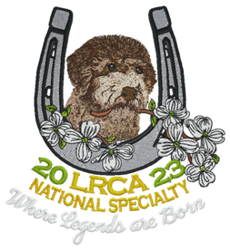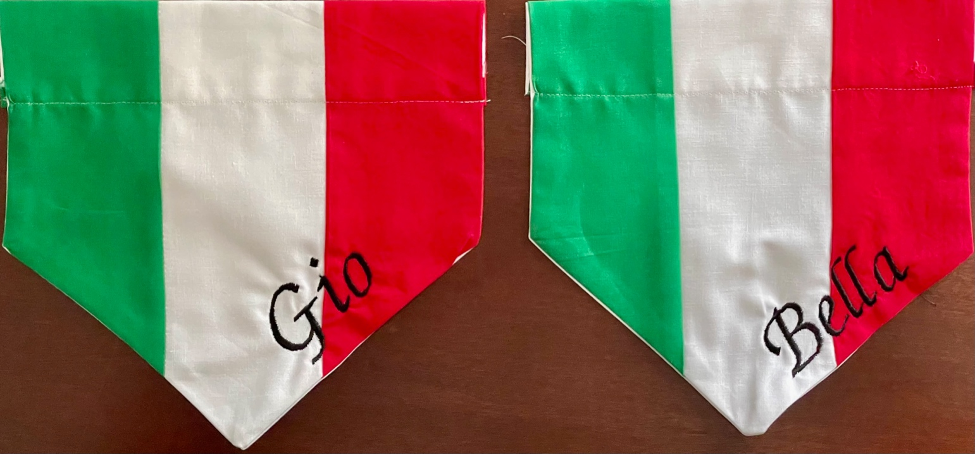

Show Committee
Jim Talbert, Carolyn Talbert, Jean Davis-Barger, Kris Harner, Kathy Hollinger

Grooming
- There will be NO grooming inside the Pavilion (We would need to pay janitorial services if we groomed)
- Grooming would be available at your RV, Auto, outside under your pop-up tent, or inside the main show hall down the hill in the Day Crate section where electricity is available and just a short walk from the Pavilion.
- Show & Go inside the Pavilion

Crates
- Crates may be placed inside the Pavilion.

Tents
- There is ample space around The Pavilion for your pop-up tents and chairs on the lawn.

Chairs
- Please bring your favorite folding chair.

Show Volunteers To Date with more coming. Thank you….
- Adrienne Perry, Bradley Burkes, Denise Peters, Susan Couch, Tammy Vann, Hilarie Gibbs-Sykes, Jamie Soucie, Ann Sweeting, Noelene Shoemaker,

Board Decision by Vote Passed on 26 October 2022
Motion that because the Lagotto Romagnolo is a low entry breed, and because we have limited personnel working on the 2023 National Specialty, any Board Members, or member of the 2023 National Specialty Committee, may enter their dog(s) in the National Specialty.

Not part of this passed motion. It was observed at the Club Italiano Lagotto 2022 Raduno, with 271 entries, that the Board Members showed their own dogs in competition.

Contact JimTalbert AKCLagotto@Yahoo.com, with any questions about the show.

